
RAMAIAH
Institute of Technology
USN | 1 | M | S

(Autonomous Institute, Affiliated to VTU)
(Approved by AICTE, New Delhi & Govt. of Karnataka) Accredited by NBA & NAAC with ‘A’ Grade

SEMESTER END EXAMINATIONS – JANUARY 2019

Course & Branch | : | B.E: Electrical and Electronics Engineering | Semester | : | VII
Subject | : | Generation , Economics and Reliability Aspects of Power Systems | Max. Marks | : | 100
Subject Code | : | EEE20/EEPE42 | Duration | : | 3 Hrs

Instructions to the Candidates:
- Answer one full question from each unit.

 |  | UNIT- I
1. | a) | With the help of block diagram describe the working of diesel power plant. | CO1 | (08)
 | b) | Discuss the socio and economic impacts of power plants. | CO1 | (07)
 | c) | Enumerate the factors to be considered in selection of site for hydro power plants. | CO1 | (05)
2. | a) | Discuss the role of following units in nuclear reactor:  - Moderator ii) Reflector iii) coolants. | CO1 | (09)
 | b) | List the different mechanism for restructuring of power systems environmental benefits. | CO1 | (05)
 | c) | Explain the pros and cons of a thermal power plant. | CO1 | (06)
 |  | UNIT- II
3. | a) | Define Demand factor and plant utilization factor. | CO2 | (04)
 | b) | A 200 MW station has following costs its capital costs is Rs350x10⁶  Taxes-Rs 5x10⁵ ,fuels Rs 7x10⁶ Transportation is Rs10x10⁵ Salaries-Rs 1.2x10⁶ Miscellaneous-Rs2x10⁵ interest and depreciation is 12%. Find the cost per kWH if the load factor is 0.6. If the load factor is improved to 0.75 and with increase in the fuel cost by 10 % calculate the changes in the cost. | CO2 | (10)
 | c) | A supply is offered on the basis of fixed charges of Rs 30 per Annum plus 30 paise per unit or alternatively at the rate of Rs 6 per unit for first 400 units per annum and 5 paise for additional units. Find the number of units taken per annum for which cost under two tariffs becomes equal. | CO2 | (06)
4. | a) | A generating station has a maximum demand of 75MW and load factor is 0.4.Generating cost is Rs60 per annum per kW of maximum demand plus 4 paise per kWh transmitted. Annual capital charges of transmission system are 20 lakhs and distribution system are 15 lakhs. Diversity factor of transmission and distribution system is 1.25 and 1.25.Transmission and distribution system are 90% and 85 % efficient. Find yearly cost per kW demand, cost at substation and consumer premises. | CO2 | (10)
 | b) | It is proposed to supply a load with a maximum demand of 100MW with a load factor of 0.4. Following three alternatives are available.  Calculate overall cost/kWH and suggest cheap alternative. | CO2 | (10)
  Cost | Nuclear plant | Hydro plant | Steam plant
  Capital cost/kW installed | Rs 6000 | Rs 4320 | Rs 2160
  Interest | 10% | 10% | 12%
  Depreciation | 8% | 7% | 10%
  Operating cost /kWH | 12 piase | 6 paise | 18 paise
  Transmission & Distribution cost /kWH | 0.24 paise | 0.96 paise | 0.24 paise
 |  | UNIT- III
5. | a) | Differentiate between adequacy and Security aspects of reliability. | CO3 | (05)
 | b) | List the factors effecting the reliability of the power systems. | CO3 | (05)
 | c) | A small generating plant is design to satisfy a constant 10 Mw load  Three alternatives are being considered i)1x 10 MW unit ii)2x10 MW unit iii)3x 5MW unit . Prepare the capacity outrage probability table for each of three alternatives. | CO3 | (07)
 | d) | Expand the following abbreviation:  i)LOLE ii)EENS iii)EIU. | CO3 | (03)
6. | a) | What are the properties of Markov chain probabilistic techniques and mention its applications? | CO3 | (06)
 | b) | Enumerate the difference between Two state & Three state model | CO3 | (04)
 | c) | For the following LDC curve shown in Fig.6(c) calculate the EIR with system having three identical units of having capacity 100 MW with FOR 0.02?  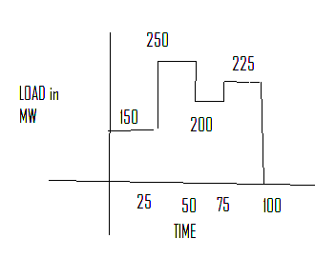  Fig.6(c) |  | (10)
 |  | UNIT- IV
7. | a) | Discuss the adequacy evolution of HL-I in reliability domain. | CO4 | (06)
 | b) | Classify the outages in power system. | CO4 | (06)
 | c) | For the following curve shown in figure 7(c), find the EIR with system having two units with capacities 25Mw & 50 Mw which have repair rate as 0.49 f/year & failure rate as 0.01 f/year ?  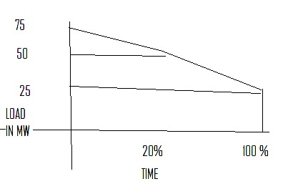  Fig. 7(c) | CO4 | (08)
8. | a) | Discuss capacity and energy based approach in reliability assessment. | CO4 | (08)
 | b) | Differentiate between ENEL and U of S approach. | CO4 | (06)
 | c) | Explain contingency enumeration approach with flowchart. | CO4 | (06)
 |  | UNIT- V
9. | a) | Discuss the assumptions made interruption scenarios for different customer. | CO5 | (06)
 | b) | Find SAIFI, SAIDI, CAIDI, ASAI and ENS for the following set of customer data: | CO5 | (10)
  Line | Failure rate | Interruption duration in mins | No of customers | Avg load demand
  A | 0.20 | 1.20 | 200 | 1000
  B | 0.30 | 1.68 | 150 | 700
  C | 0.45 | 2.88 | 100 | 400
 | c) | Explain the terms CAIFI and ASAI. | CO5 | (04)
10. | a) | Compare smart grid vs traditional grid. | CO5 | (07)
 | b) | Discuss the five key aspects required for smart grid development. | CO5 | (07)
 | c) | Discuss the importance of reliability evaluation in smart grid. | CO5 | (06)

****************

